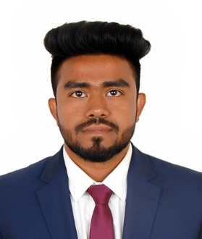
Sabbir Rahman
West Kazipara, House No: 657, Mirpur-1216, Dhaka
📞 01741289592 | ✉ sabbirrahman4t@gmail.com
Permanent: Vill: Boro Parulia, P.O: Kashiyani, P.O Code: 8130, Gopalganj

Career Objective
To leverage my expertise in software support, technical troubleshooting, and international data entry projects to deliver efficient client solutions and contribute to organizational success.

Key Skills & Competencies
- Software Support & Troubleshooting
- Data Entry & Information Management
- Networking & Problem Solving
- HTML, CSS, MS Office, Adobe Photoshop
- Communication, Teamwork & Time Management

Professional Experience
Support Engineer – Smart Software Solutions Limited | Sep 2025 – Present
- Provide software and technical support to clients and monitor system performance
- Assist in system configuration and problem resolution
Data Entry – Russian Project
- Managed large volumes of data efficiently
- Coordinated with international teams and ensured timely submissions

Education
B.Sc. in Computer Science & Engineering – Northern University Bangladesh | 2016 – 2019 | CGPA: 2.76
Diploma in Computer Engineering – Gopalganj Model Polytechnic Institute | 2011 – 2015 | CGPA: 3.18

Projects & Training
- Russian Data Entry Project – Managed large-scale international data entry tasks
- Web Page Design Project – Developed responsive HTML & CSS pages
- Industrial Training – Web Page Design, Gopalganj Model Polytechnic, 6 months (2015)
- Government Computer Training – IT Support, BITM, 3 months (2018)

Languages
- English – Good (Speaking, Reading, Writing)
- Bengali – Excellent

References
- Md. Samsuddoha Alam – Assistant Professor, Northern University Bangladesh | 01676-453189 | msdohanub@yahoo.com
- Dr. Ataur Rahman – Professor, University of Dhaka | 01711-071517 | ataurrahman74@yahoo.com

Declaration
I hereby certify that the above information is true and correct to the best of my knowledge.
……………………………………
Signature

